
College of Engineering, Environment and Computing
School of Science

Part of MSc Cybersecurity
7005SCN Individual Research Project

Developing a fileless malware detection tool for combating cyber-attacks in SMEs without dedicated cybersecurity expertise:

Policy – Artefact 2

By

Alexia Petrescu
SID: 12281912

1st Supervisor: Kabiru Mohammed
Submitted in partial fulfilment of the requirements for the Degree of Master of Science in Cybersecurity

Academic Year: 2025/26

Table of Contents:
Table of Contents: 2
UK Standards and Guidelines: 4
ICO Guidelines and UK GDPR: 4
Preparation: 5
Enabling Sysmon 5
Enabling PowerShell 6
Python and Library Installation 8
Configuration: 9
Baseline 9
Backups: 9
Risk Tiers and Meaning: 10
Detection 11
PowerShell Command Checker 11
Office Macros Checker 12
UAC Checker 14
Start-up Checker 16
References: 19

Table of Figures
Figure 1 5
Figure 2 5
Figure 3 6
Figure 4 6
Figure 5 6
Figure 6 7
Figure 7 7
Figure 8 8
Figure 9 8
Figure 10 9
Figure 11 11
Figure 12 12
Figure 13 13
Figure 14 13
Figure 15 14
Figure 16 14
Figure 17 15
Figure 18 16
Figure 19 16
Figure 20 17
Figure 21 18

Table of Tables
Table 1 8
Table 2 11
Table 3 13
Table 4 16
Table 5 17

UK Standards and Guidelines:
As this project concentrates on UK SMEs, the following rules and guidelines stated by the government regarding cyber security and procedures need to be followed in case of an attack. This are of the policy also covers the legal guidance as the aftermath of an attack.

ICO Guidelines and UK GDPR:
UK General Data Protection Regulation (GDPR) requires organisations to report within 72 hours of a personal data breach; therefore, SMEs should have a plan regarding reporting attacks. A personal breach is defined in the Information Commission’s Office (ICO) guidelines as: "the accidental or unlawful destruction, loss, alteration, unauthorised disclosure of, or access to, personal data" (ICO, 2023). The area of personal breach that is encapsulated by the policy/prototype for this project is a security incident orchestrated by an attacker. However, SMEs should have plans for all other potential personal breaches as well.
The (ICO) is the information rights regulator and should only be notified if the breach leads to the loss of control of personal data, or the unlawful unauthorised use of the data by a 3rd party, such as identity theft or fraud (ICO, 2023). The individuals affect should only be notified if the breach leads to risk to their rights and freedoms, such as patient records in a hospital. This section differs based on the nature of the data held within the SME.
The ICO provides an Information Security Checklist for small and medium organisations to fill out, which will give back a colour based on how secure the organisation is (ICO, n.d.). This guide includes questions about what the company is doing to manage security risks, what policies they have in place, how they are using 3rd parties, etc.
The National Cyber Security Centre (NCSC) aids business in device protection by providing cyber security guidance and tools (NCSC, 2026). They have provided a Cyber Assessment Framework aimed at essential service sectors that aids organisation to meet legal requirements for cyber security (NCSC. 2025). It provides a framework that can assist organisations in cyber assessments and improvement. It provides scenarios involving common types of cyber-attacks, aiding the business in comprehensively creating their own security protocols.

Preparation:
The prototype uses logs of events that occur on the device to check whether suspicious activity is taking place. These logs can be found in Event Viewer. However, devices do not come pre-installed with checking for all of the logs required for the prototype, and therefore certain areas of Event Viewer need to be configured to gain access to those events. The prototype requires the event logs of Sysmon and PowerShell script logging to be installed on the device. The configuration file for Sysmon is found on GitHub, along with the prototype, files which need installation before the first steps can begin (Petrescu, 2026).

Enabling Sysmon
For Sysmon the following commands need to be types in PowerShell, running as administrator (Microsoft, n.d.):
- Enable-WindowsOptionalFeature -Online -FeatureName Sysmon
- sysmon.exe -accepteula -i sysmonconfig-petrescua_add-on.xml
Figure 1- the code required to enable Sysmon
The .xml file (Figure 1) is a particular configuration of Sysmon that allows the users to view more events then default configurations, which allows the prototype to read everything that it needs to. For example, this configuration enables Event Log 1 and has conditions to check for a plethora of areas within Windows, including Network services, what is being launched, what permissions are being given, what configurations are being set, as so on. For the prototype, there has been one area which was built upon from the configurations file, that is in Event Log 13, where logs for all User Account Control (UAC) values have been added. More on this change in “Configuration” section.
After enabling Sysmon to operate on the device, in Event Viewer, the operational section will be found under Application/Microsoft/Windows/Sysmon/ Operations (Figure 2). This is one of the areas from where the scrip gains the event log.
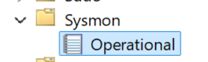
Figure 2 – the end of the path in Event Viewer

Enabling PowerShell
To configure PowerShell Script Logging:
Press Windows + R, Type gpedit.msc (Figure 4)
Navigate to: Computer Configurations/Administrative Templates/Windows/Components /Windows PowerShell (Figure 5)
In the Setting Selection, right Click on Turn on PowerShell Script Block Logging (Figure 5)
Select Edit
Then, Select Enabled (6)
Figure 3 – Step by Step Guide on Enabling PowerShell Script Block Logging
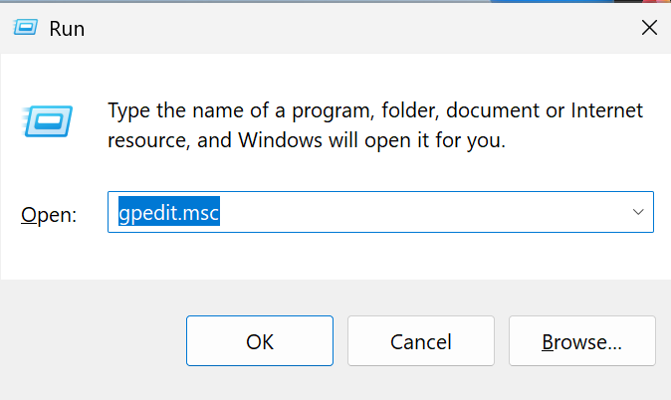
Figure 4 - Window pop up when initiating step one
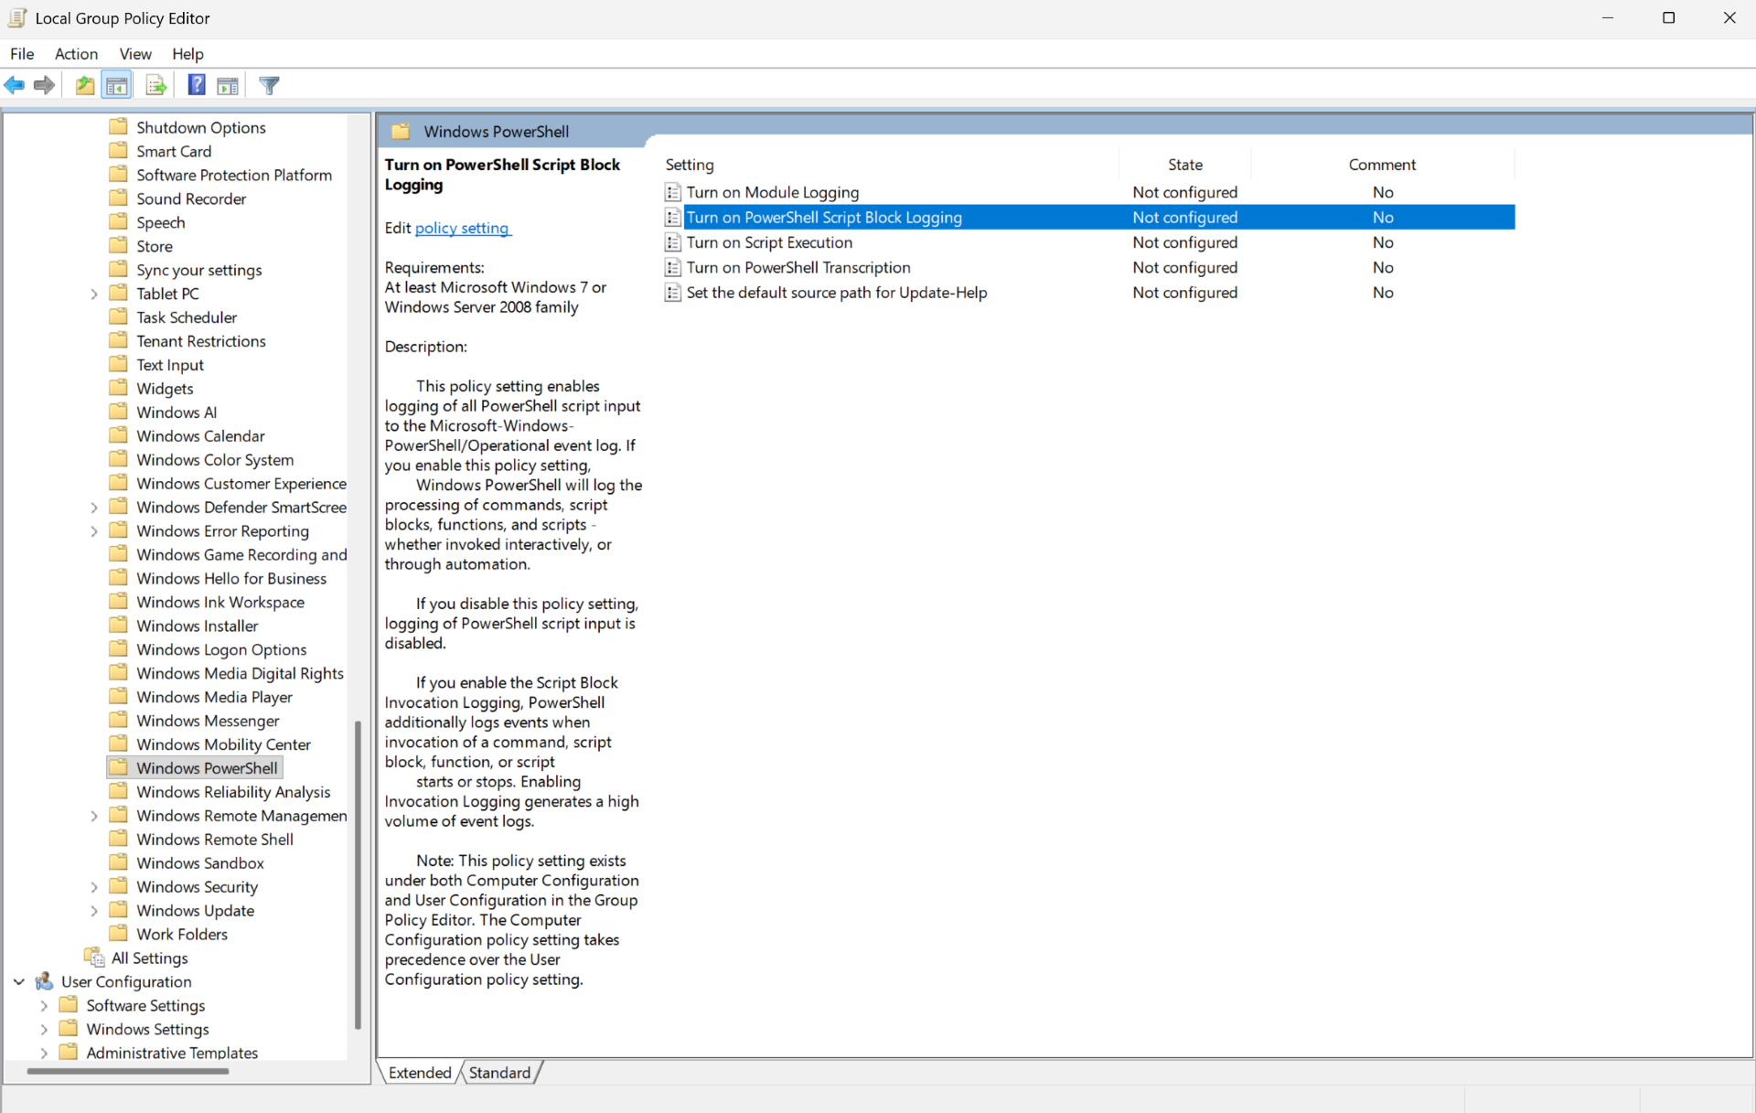
Figure 5 - Window pop up to navigate to for step two, and where to click to enable for step three

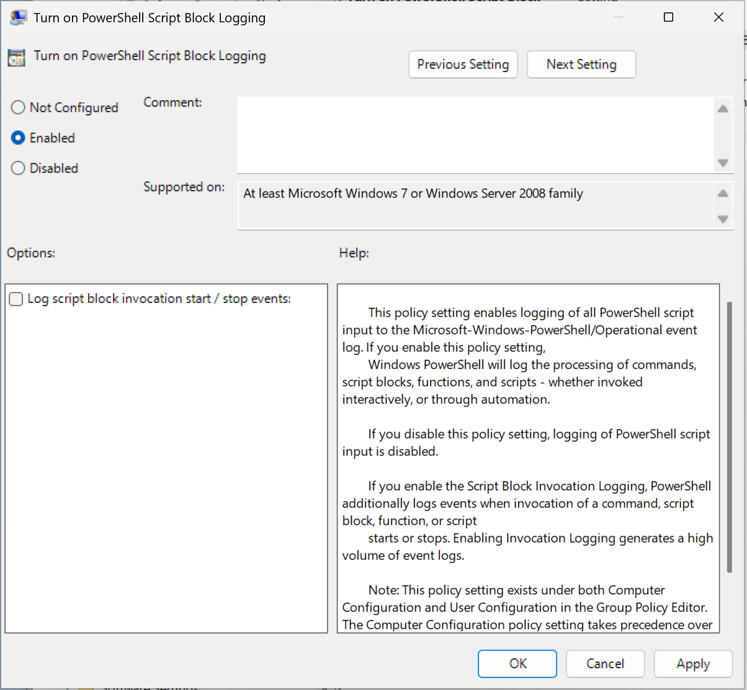
Figure 6 – Window to enable PowerShell Logging
After enabling PowerShell logging to operate on the device, in Event Viewer, the operational section will be found under Application/Microsoft/Windows/Sysmon/ Operations (Figure 7). This is one of the areas from where the scrip gains the event log. Event log 4104 will be checked for any potentially malicious commands.

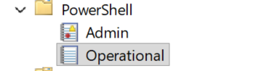
Figure 7 – the end of the path in Event Viewer

Python and Library Installation
After the installation of Sysmon and PowerShell Script Block Logging, Python as well as all the libraries required need to be installed, for the prototype to run. Python can be installed from the official website. Many libraries come already installed in python such are .re (used for the search feature) and sys (used to read and understand system errors), however some others need to be installed, such as “Evtx Reader”.
The following table shows which libraries are needed, and weather they need to be installed:
Usage | Library | Does it require Installation?
Evtx file reader | Evtx event logs (Python, 2025a) | Yes
String Matching | Regular Expression (Python, n.d.-c) | No
Windows Notifications | Windows-Toasts (Python, 2025b) | Yes
Admin enabler | C-Types (Python, n.d.-a) | Yes
CSV file read/writers | CSV (Python, 2020) | No
File path existence | OS (Python, n.d.-b) | No
Running commands | Subprocess (Python, n.d.-d) | No
Exiting Program if required | SYS (Python, 2026a) | No
Access to Windows API | pywin32 (Python, 2026b) | Yes
Table 1 – All the libraries required for the prototype.
To install the required libraries, type one by one the following in the terminal:
pip install python-evtx
pip install Windows-Toasts
pip install pywin32
Figure 8 – code to install the libraries required.
After installation of python is completed , the prototype starts by running the following command:
Python prototype.py
Figure 9 – code to run the prototype.

Configuration:
All required configurations are installed in the preparation sections via SwiftOnSecurity's Sysmon configuration, and a few add-ons added to aid in the detection of changed in the UAC values (Figure 10).
<!--Registry Sets-->
<TargetObject condition="end with">\Policies\System\ConsentPromptBehvaiourAdmin</TargetObject>
<TargetObject condition="end with">\Policies\System\ConsentPromptBehvaiourUser</TargetObject>
<TargetObject condition="end with">\Policies\System\ConsentPromptBehaviorEnhancedAdmin</TargetObject>
<TargetObject condition="end with">\Policies\System\PromptOnSecureDesktop</TargetObject>
<TargetObject condition="end with">\Policies\System\EnableLUA</TargetObject>
<! --RDP-->
Figure 10 – code snippet that was added to the Sysmon configuration file. Full file available on GitHub
The prototype also uses the default PowerShell Script Block Logging configurations.

Baseline
There are areas within the script that act as baselines which events are checked against. This can include new entries in the start-up folder, new macros used by the SME or changes to the UAC values made by the employees. If these changes are not placed into the baseline sections in the script, the script will see them as suspicious and report them. These areas in the script include the “UAC-Rules” dictionary for changes in UAC, the “risk-low” list for macro functions and the “Known-baseline” for start-up folder paths and files.
Currently, users of the prototype need to go into the script file and change these areas manually, however future iterations of the prototype will work to make this section easier.

Backups:
Ransomware attacks are one of the most devasting malware attacks that attackers use. In this type of attack, attackers take all the most important and valuable data the SME stores and threaten monetary compassion or the data is released publicly. The best resolution would be for the attackers to never get access to the data; however, this can be challenging to accomplish without adequate defences. A good alternate option is to keep a backup of all important data, documents, and information which would be stored with minimal access to it, so attackers cannot delete it and SMEs would at least still own their data.
Offsite storage of data in a remote location can be further beneficial as it is much harder to access by attackers. Furthermore, keeping multiple copies of the data and storing them in multiple types of storage, for example keeping it on a local hard drive as well as on cloud storage can be beneficial to retaining data even if under a cyberattack (NCSS, 2026).
Chin (2026) states that companies should follow the 3-2-1 rule where there are 3 copies of the business’s data, 2 on different storage devices and one offsite. The author further elaborates that this method allows for the smallest rate of financial loss under a cyberattack, as data has the least chance of being all lost. To copy data back-up on a hard drive, the business can use the device’s native backup software or a reliable 3rd party application.

Risk Tiers and Meaning:
The prototype can have 3 tiers of Risk: Low, Medium and High. Any low-risk activities will not be flagged, and only Medium and High-risk activities will be written as part of the .csv file. Medium risk for this prototype is often associated with events that do not fall into the baseline, but do not fall into the risk/suspicious category either.
This area can be distinguished as an employee forgetting that they ran a command that may look suspicious but was not or forgetting that they added a shortcut to the star-up folder without adding to the baseline.

Detection
This next section will go in depth at what each part of the code does and how to interpret the results.

PowerShell Command Checker
When running the prototype, if the script finds any suspicious commands have been ran in PowerShell, regardless of if the user ran them or an application, they would show up in a table under “Pattern_Matching_Report.csv” (Table 2). This table shows the time the suspicious command happened, what caused the script to see it as suspicious, the risk level determined by what was ran, and the command itself, so the user can see what occurred. The script also sends out a notification to the user, regardless of outcome (Figure 11). If a suspicious command has already been logged with the same event ID and time, it will not appear again.
Event ID | Timestamp (UTC) | Category | Risk Level | Command
4403 | 12/10/2026 15:48 | Command was Encoded | High | powershell –enc AVGVGHSgaHGV
4409 | 12/10/2026 15:49 | Command was Encoded | High | powershell -enc
Table 2 - Showing .csv file example output after running the prototype – pattern matching specific.
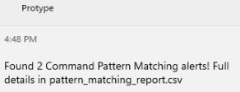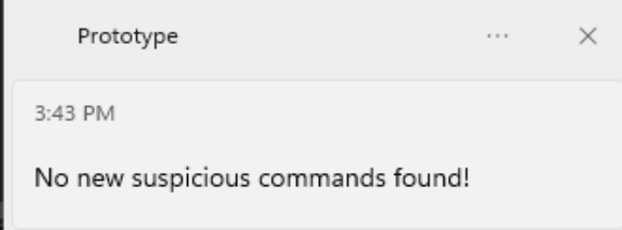Figure 11 – Showing the message shown by the prototype when a suspicious command has been found (Right) and when nothing suspicious was found (Left)
There are multiple types of suspicious commands that the prototype finds, listed below, taken from the prototype script (Figure 12). These are a combination of commands that have been known to be part of fileless malware techniques, as well as suspicious commands that an SME employee will likely not run. For example, attackers, after gaining access to the device of the victim, are known to download some of the tools that that may need to the device and could use command arguments such as “curl” or “Download String”. If these arguments are found, they are given a score, in this case “3”, which will add to the overall risk score for the example command.
The more suspicious arguments a command has, the higher the score it will show. The list has been developed for SMEs which would not normally run commands in PowerShell and therefore would not use “curl” or any other arguments to download files to the device. This list is not an exhaustive list for suspicious commands an attacker could run; however, it is compressive enough for the alpha version of the prototype.
The “Event ID” is the number given by Event Viewer to keep track of events in chronological order. This means if Event Viewer is opened, by searching for the event ID number, the raw event would also come up.
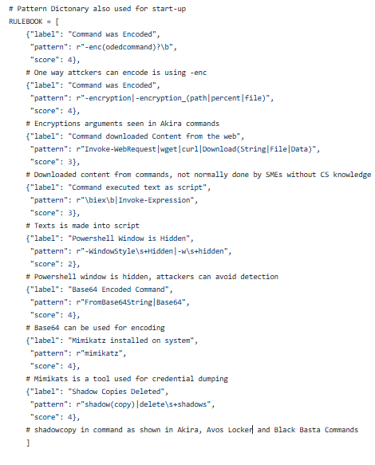
Figure 12 – The command checking dictionary which triggers the user to get a notification when one is found on the system

Office Macros Checker
An office Macro is described as a set of actions that are ran to automate a task (Microsoft, 2024)
. This task can be anything like helping the user write table headers in, or automating a file formatting, however they can also be used to open PowerShell and run commands, making them cable of malicious activities. If the prototype finds any suspicious macros, the prototype will return both a notification and a table showing the results found (Figure 13, Table 3) The notification will show the user where to find the full details, macro_report.csv, whilst the table will show what the prototype has found.
The table will show which Office application has run the macro, for example, word, excel or PowerPoint, the risk level determined by the script, what the macro has done, and which document ran the macro. This last section is very important, as from there the user can determine where the document has come from, such as a suspicious email, and can flag it at suspicious.
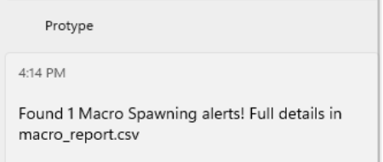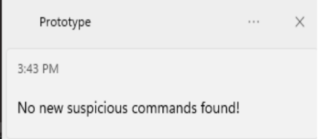
Figure 13 –the message shown by the prototype when a suspicious macro has been found (Right) and when nothing suspicious was found (Left)
Event ID | Time (UTC) | Category | Risk Level | Command | Command Risk | From Document
116727 | 12/10/2026 11:08 | Office app WINWORD  .EXE ran powershell  .exe | High | powershell.exe -w hidden -enc &amp; Base64Encoded  TestCommand () | Command was Encoded; Base64 Encoded Command | Macro  _setup.docx
Table 3 - cvs file example output after running the prototype – macro specific.
If macros are enabled on a device, some non-suspicious macros may also appear in this section as Microsoft may run their own macros to start certain applications. All the ones found are part of the safe baseline in the prototype (Figure 14). For example, one of the ones found during testing was “ai.exe, which is a part of Office that brings AI functionality to the applications such as Word and Excel (Bryntze, 2024).
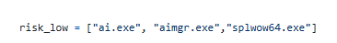
Figure 14 – part of the script which creates a baseline of possible non-suspicious Macros executables that Microsoft run themselves for certain applications
The recognition part of the script checks if the application that the macro has opened is in the “risk_low” section or in the “risk_image” section, or in an unrecognised state (Figure 14, Figure 15). Anything in the unrecognised state is given a “Medium” risk and can either be added to the low-risk area or the high-risk area after it has been checked.
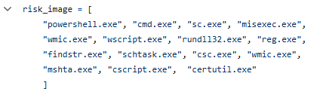
Figure 15 – part of the script which creates a risk list for executables that Macros may start. If it is part of this list, the prototype will write it in the table.

UAC Checker
The prototype checks for the change in 5 areas as part of the UAC (Figure 16); however, this section can be different based on the device configurations of UAC. Usually, the higher the number associated with each section, the more secure the controls would be, such that if “Consent Prompt Behaviour Admin” is for example 5, it may even require a password to pass it, but if it is 0, then the window will not be shown to the user. This area can be changed by attackers as they attempt to move through the device, and consequently throughout the network, in such a way that they will not get detected.
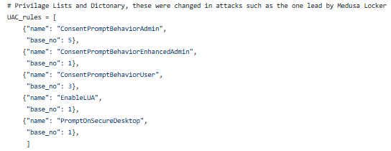
Figure 16 – part of the script which creates a risk a dictionary for the UAC sections the prototype checks any change for.
The value requirements for each area can be found in the registry my going to the path HKEY_LOCAL_MACHINE\SOFTWARE\Microsoft\Windows\CurrentVersion
\Policies\System (Figure 17). There, the user can find each area specified in the prototype, and under “Data”, the value required by the prototype to be the “correct value” is shown.
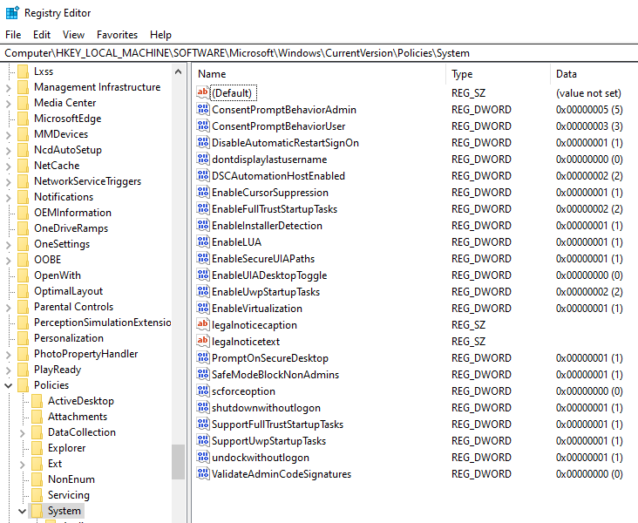
Figure 17 – The Registry path for finding all the correct UAC values, including the name and numerical value
The prototype sends the user a notification if the value of any of these rules has been changed (Figure 18). Following the notification, the user can check the UAC specific table which will give them all the information available from the event (Table 4). This section does not show how it was changed, only that it was changed by a specific application. The table also shows the user the original value, and the value it has been changed to, regardless of what that changed was, as seen in the example table.
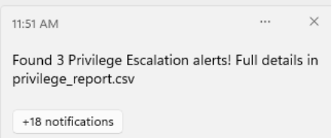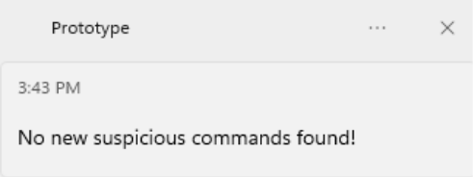Figure 18 – the message shown by the prototype when a UAC change has been found (Right) and when nothing suspicious was found (Left)
Event ID | Timestamp (UTC) | Category | Risk Level | Expected Value | Changed to | Changed by
123885 | 13/10/2026 09:33 | Enable LUA | High | 1 | 0 | powershell.exe
123960 | 13/10/2026 09:36 | Enable LUA | High | 1 | 3 | powershell.exe
124200 | 13/10/2026 09:50 | PromptOnSecureDesktop | High | 1 | 0 | powershell.exe
Table 4 - .cvs file example output after running the prototype – privilege checking specific.

Start-up Checker
Attackers may use persistence measures to remain in a device, to either extract as much data from the victim, or to be able to navigate through to other devices. To achieve persistence, they may put their tools, or a link to their application in the start-up folder, so that when the device is restarted, they applications and tools are also restarted. This keeps the malware active in the device. The prototype checks for any new, unrecognised short-cuts or other files in the start-up folder, and gives the user a notification based on its findings (Figure 19). The user can then check the table created from the findings and see the shortcut path created what that shortcut is leading to, and lets the user know if the signature of the file is valid. Just because a file is valid, does not mean it cannot be used maliciously (Table 5).
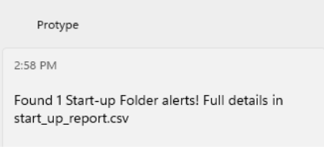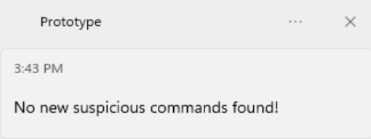Figure 19 – the message shown by the prototype when a suspicious start-up check has been found (Right) and when nothing suspicious was found (Left)
Event ID | Timestamp (UTC) | Category | Path
126867 | 13/10/2026 13:33 | Startup Folder | C:\Users\vboxuser\AppData\Roaming\Microsoft\Windows\Start Menu\Programs\Startup\Test_powershell.lnk

Risk Level | Target | Type | Reason | Signature Status
High | C:\Windows\System32  \WindowsPowerShell  \v1.0\powershell.exe | Shortcut | Suspicious base image in Startup Shortcut, Shortcut may safe, please add to baseline if recognise | Valid
Table 5- .cvs file example output after running the prototype – startup folder checking specific. The table is split into two for formatting purposes, however in the csv file there is only one table
This part of the prototype takes the base name of file that is either in the start-up or that is what the short-cut directs to, and checks if its part of the high-risk list it has (Figure 15). The additional reason “Suspicious base image in startup shortcut” is shown if that is the case. Furthermore, it checks for the location of the base file, and depending on where it is found, the second reason is shown. This location can either be “safe”, “suspicious”, or “unrecognised” (Figure 20) If the prototype finds an unrecognised short-cut, it lets the user know that they may add it to the baseline, if they are the ones that have added it.
The Signature Status section way show: “Unknown, likely unable to validate. Input was [path]”. If this is there may be multiple reasons behind that, including the file not originating within the device, or the path showing to a directory rather than to a file. This is why the script will return the path, as that can be visually checked by the user, and more information can be gained. If the file originates from download folder, it can be determined that the user may have installed said path onto the device.
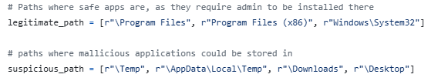
Figure 20 – the list of the legitimate and suspicious paths, otherwise it is shown as “unrecognised”
Additionally, the prototype contains a known-baseline check, which are made up of baseline of shortcuts that can be safe, and files that the shortcut may create outside of the short-cut file (Figure 21). To create a shortcut, the Event Viewer captures 4 different events, only one of which has the name of the file link. The other names have been added to this baseline, as they do not produce any meaningful data for the event, just that the device has created a shortcut. These files would just overpopulate the start-up table and cause user confusion.
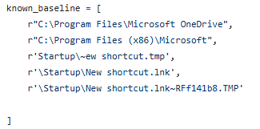
Figure 21 – the baseline used for the prototype, including the 3 temporary files produced in tandem with the shortcut file

References:
Bryntze, J. (2025, January 20). What is ai.exe and why is it running? groovyPost. https://www.groovypost.com/explainer/ai-exe-why-running/
Chin, K. (2026, July 28). HOW TO BACK UP YOUR DATA: 6 Effective strategies to prevent data loss | UpGuard. Www.Upguard.Com. https://www.upguard.com/blog/how-to-back-up-your-data
ICO. (n.d.). Information security checklist. ICO. Retrieved https://ico.org.uk/for-organisations/advice-for-small-organisations/getting-started-with-gdpr/data-protection-self-assessment-medium-businesses/information-security-checklist/
ICO. (2023, May 19). A guide to data security. Ico.Org.Uk. https://ico.org.uk/for-organisations/uk-gdpr-guidance-and-resources/security/a-guide-to-data-security/
ICO. (2025). Personal data breaches: A guide. Ico.Org.Uk. https://ico.org.uk/for-organisations/report-a-breach/personal-data-breach/personal-data-breaches-a-guide/
Microsoft. (2024). Quick start: Create a macro | Microsoft Support. Microsoft.Com. https://support.microsoft.com/en-us/excel/get-started-with-excel/quick-start-create-a-macro
Microsoft. (2026, February 24). Enable and configure sysmon in windows. MicrosoftLearn. https://learn.microsoft.com/en-us/windows/security/operating-system-security/sysmon/how-to-enable-sysmon
NCSC. (2025, August 26). Cyber assessment framework. Www.Ncsc.Gov.Uk. https://www.ncsc.gov.uk/collection/cyber-assessment-framework
NCSC. (2026, July 21). National cyber security centre. National Cyber Security Centre. https://www.ncsc.gov.uk/collection/small-organisations-guide-to-cyber-security/backing-up-your-data
Petrescu, A. (2026). GitHub - petrescua/7005SCN--Individual-Research-Project-Alexia-Petrescu: Artefact 1 and 2 for dissertation submission, including prototype file, test files and the policy written the dissertation. GitHub. https://github.com/petrescua/7005SCN--Individual-Research-Project-Alexia-Petrescu

